Software Design Specification

For

BOT COUNSELLER

Prepared by
MUHAMMAD HASSAN (1612195)
MUHAMMAD DANIYAL(1612238)
2ND DECEMBER 2019

1. Introduction
1.1 Purpose of this document
This software design document describes the architecture and system design of Bot Counselor, a question answering system for education industry. It is intended to outline the system structure for the project manager and stakeholder, and provide technical guidance to development team.

1.2 Scope of the development project
This will be similar to what was written in the SRS. Bot Counselor is an AI chatbot that receives questions from the user, tries to understand the question and provide appropriate answer. It does by converting and English sentence into machine friendly query, looking up in trained model for necessary information to answer the question and finally returning the answer in natural language.

The main objective is to develop a bot that provides such service that will help the user in selection of the undergraduate field.

The goal is to provide the students of intermediate and A-level to provide counselling about, which field they should enroll in.

1.3 Definitions, acronyms, and abbreviations
- Chatbot: An interface, usually text based, specializing in mimicry of natural language conversation.
- HTML: Hyper Text Markup Language, a standardized system for tagging text file to achieve font, color, graphic and hyperlink effects on webpage.
- JSON: JavaScript Object Notation, a data interchange format that is commonly used in exchanging the data over the internet.
- Flask: it is a python framework for the development of web application.
- Neural network: it is an Artificial Intelligence concept for the training of machine
- MVC: Model View Controller. It is now considered as standard concept/framework for the development of web application
- Pymongo: it is a library of python for connection of data base and transection of data from database

1.4 References
- For content related: http://www.cci.drexel.edu/SeniorDesign/2016_2017/DrexelChatbot/DrexelChatbotDD.pdf

1.5 Overview of document
- Introduction: provides an overview of application, explains objective and goal of project and describe the structure of document
- System over view: gives general description of functionality of context and design of bot counselor.
- System architecture: break the project down into various subsystems, defines how those subsystems interact.
- Data design: describes the organization of data in mongodb database implemented for bot counselor.

2. System architecture description

  - Section Overview

Most of the search engines today, like google, use a system to rank web pages. When user enter a query, the query is interpreted as keyword and system returns list of highest ranked web pages which may have answer to query. Them user must go through web pages to find the answer they are looking for. Bot counselor, however, will try to understand the query and provide a definitive answer.
  - General Constraints
as the application is developed in python, the only limitation of end result will be the speed of the bot. to overcome this issue, it is advised to the user to have a high-speed internet connection and a good processor, this will be beneficial for the user.

  - Data Design

    - Database design
Username | Varchar (unique)
Email | Varchar (unique)
Password | Varchar
Id | Int (unique)

message | Varchar
messageBy | Varchar
Time | Time
userId | Int

    - Dataset questions
Questions | Option A | Option B | Option C | Option D | Option E
About Youth | Help others | Explore world | Make money | Build stuff
Well done job? | Assets | Neat environment | Creating something | Solving problem
Ultimate goal | Understand humans | Invent something | Be president | Make better world
Interested in | Technology | Learning computer | Intellectual ideas | Knowing nature
You like to do | Singing | Vlogging | Computing | Surfing internet | Thinking ideas
Favorite class | Performing | Human behavior | Deep thinking | experimenting
Like to help others? | Yes | No
Know how machine working | Yes | No
You are? | Ambitious | Go with flow
Socializing? | Yes | Sitting at home
Concerned about state of environment | Yes | No
Interested in body heal | Yes | No
Like working with hand and outdoor | Yes | No
Graphic\web design | Yes | No
Good at numbers | Yes | No
Work with people | Yes | No
Friends know you for | Organizer | Go with gut feelings | Showing initiative | Job done
People consider you | Risk taker | Logical | Generous | Cool headed
After 20 years | Entrepreneur | Doctor | Actor | Engineer | Computer scientist
Free time activities
.
  - Program Structure
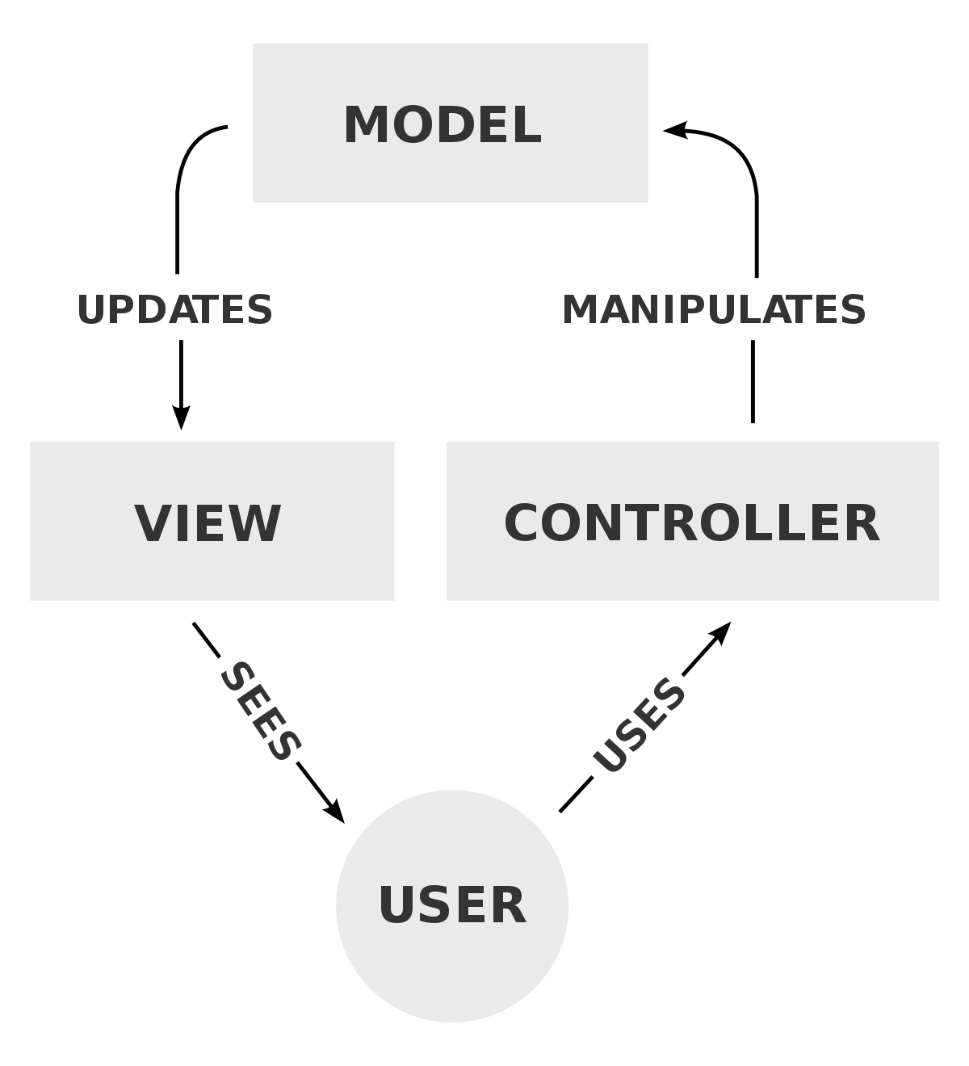
Flask is being used to develop the frontend and web application. Flask is the framework of python that is used to develop the web app. The nature of flask is minimalistic. This nature gives us a lot of freedom in how to structure our project. By getting advantage from this flexibility of the framework, the project will be based on Model View Controller concepts.

  - Alternatives Considered
N/A.

- Detailed description of components
  - Section Overview
The end product (chatbot) will be the mixture of many components. Each component will be playing a huge roll in the development of the bot. every feature of the bot will go through all the component of the bot. The components are Flask, Neural Network, MongoDB while features are chatting, sign in, sign up.
  - Component n Detail (include a sub-section for each component)

    - Flask:
Identification | Flask
Type | Initial File
Purpose | To start application and medium for user interface and server requests
Function | ‘app’ is the base attribute for the flask. Other functions are based upon this attribute. Every web page of the application has a function associated.
Subordinates | ‘Model View and Controller’ concept is implemented.
Dependencies | None
Interfaces | In views, all the pages are available. All of them are developed on bootstrap studio. So, all the interfaces are integrated in view page.
Resources | Flask itself is a resource for the application. So, it doesn’t require any resource to operate for further operation. A browser is needed to showcase the results of flask.
Processing | Flask, a framework works the way you want it to work. the is no specific structure for flask to work on. But bot counsellor will be developed using MVC frame work  Flask is initiated by creating app I,e the object of flask  app = Flask(__name__)  and route ‘/’ oi followed  @app.route(‘/’)  def <functionName>():  return <some web page>
Data | Flask does not have concern with data. It doesn’t require any data to process. It just works to send request to the server and send response to the user. Data from the form is travelled by request of flask to the server.

    - Login:

Identification | LOGIN
Type | Class
Purpose | Process by which an individual gains access to his / her profile by identifying and authenticating themselves.
Function | Login are used to gain access to and control of Users to get excess of his/her Chatroom. It requires Username and Password. This function will log in a user based being matched in MONGO-DB
Subordinates | The screen contains link to Registration Screen
Dependencies | It should be connected with the server, which is connected with the database for validation.
Interfaces | Designed using HTML, CSS, BOOTSTRAP and JAVASCRIPT using simple colors
Resources | System must be connected to MONGO-DB in order to fetch login details
Processing | Data which will be provided by the user is to validate it’s information
Data | Data is provided in login in the form of INPUT ,

    - Register

Identification | SIGNUP
Type | Class
Purpose | It will allow unregistered candidates to become a member of the system.
Function | It will register the new User. It requires the form which has to be filled by the user.
Subordinates | The screen contains link to the login page.
Dependencies | It should be connected with the server, which is connected with database for update.
Interfaces | Designed using HTML, CSS BOOTSTRAP
Resources | System must be connected to MONGO-DB in order to register user
Processing | Data which will be provided by the user will be validated.
Data | Data will be provided in the form of INPUT

    - Pymongo:

Identification | PYMONGO
Type | DATABASE connection
Purpose | It connects the database
Function | It performs crud operation using from database
Subordinates | NONE
Dependencies | NONE
Interfaces | NONE
Resources | MONGO DB should be installed
Processing | It makes connection using code and performs crud operation using code
Data | Data is saved in JSON format

- User Interface Design
  - Section Overview
Just like every chat container, bot counselor will be a simple design. And a couple of common ingredients will be there and that are login and registration form. This will help us to maintain the chat that is done with the bot. Further details are followed by headings below.
  - Interface Design Rules

N/A
  - GUI Components
GUI components are the web pages that will be shown to the user. Following are the ones that will be shown

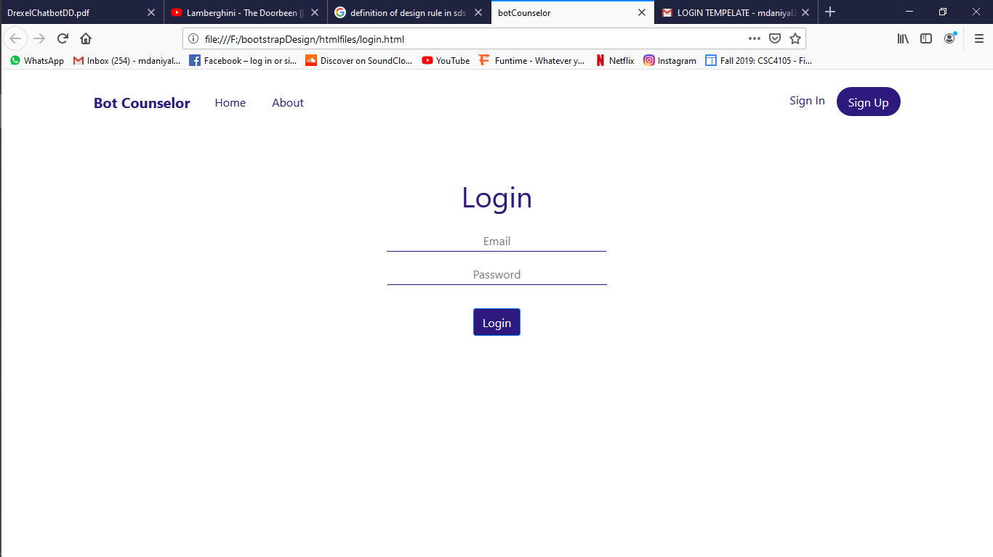

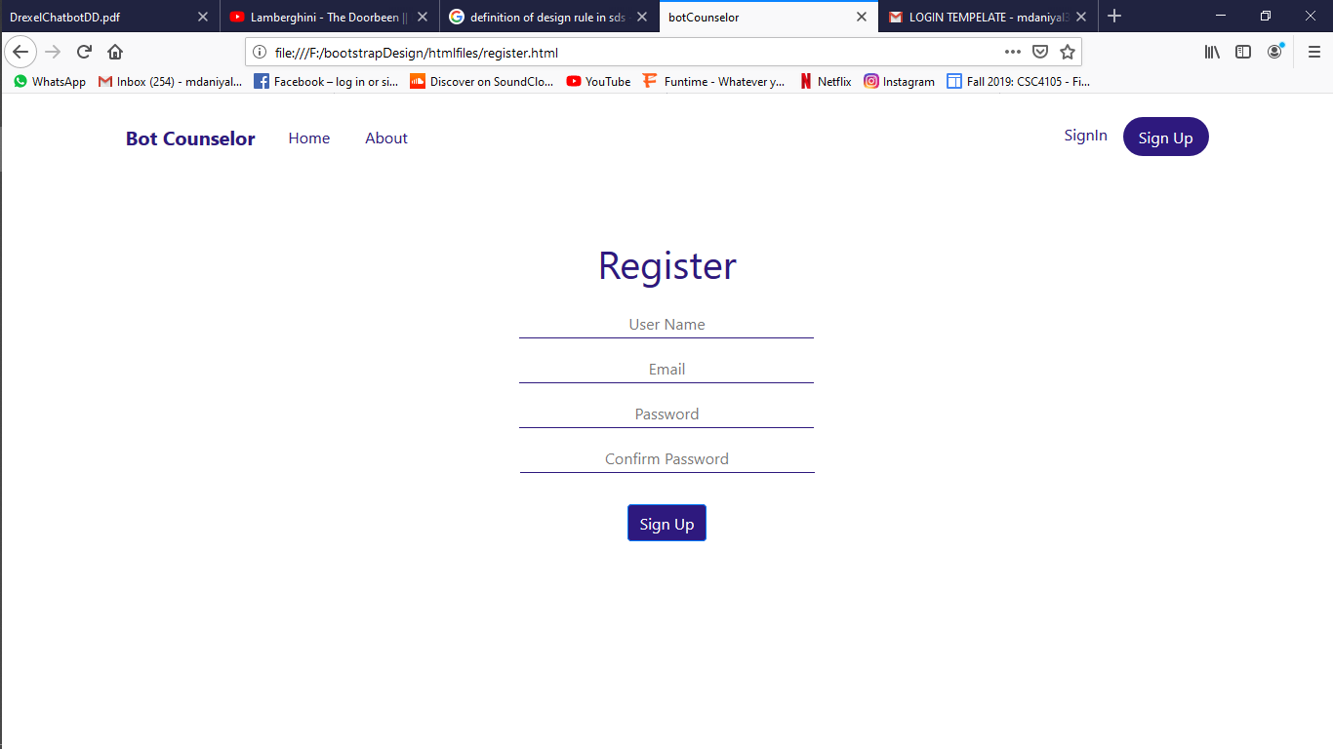

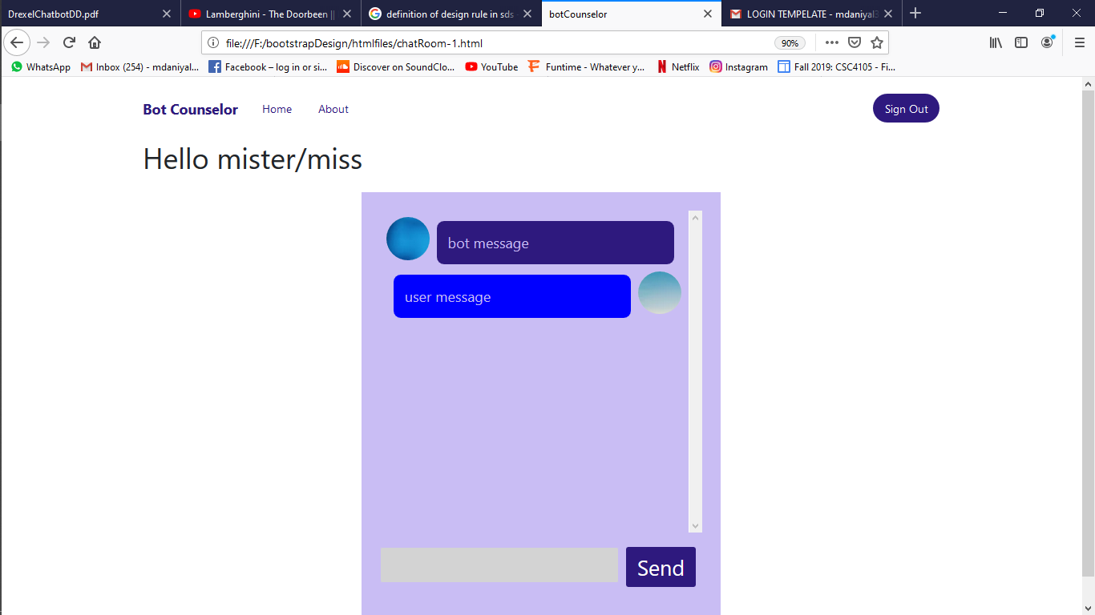

  - Detailed Description
Public login()
Input | Email, Password
Output | Page Render, error
Description | This function will take username and password as input in form and validate them. And output will result accordingly. Will be rendered to chatroom on right input or get error on bed input.

Public register()
Input | Username, Email, Password, Confirm Password
Output | Page Render, Error
Description | This function will take the mentioned fields from the from and validate whether the given information is in correct format and then generate the result accordingly.

Public send()
Input | Void
Output | Void
Description | This function will send the user entered message from designated text area and send that message to the server. Then server will respond according to the entered message.

- Reuse and relationships to other products
Just like every other software, the reusability of classes and functions will always be looked after, in order to use them in future for further modification. For the bot counselor, the class that involves training will be constant in every modification, unless any new method is found. Webpages are made using bootstrap and bootstrap’s source file will remain as it is for further development and modification. And code can be integrated in html format files. Model classes are also a part of reusable classes. And those can be modified with the advancement in features and user data requirement. In a nut shell, each and every component can be used in future for further modification and advancement in the end project. The only limitation is that the project is centralized so updating will stop the services of bot.

- Design decisions and tradeoffs
Use this section to motivate any decisions that will help the reader understand the design that your team is using. This section can also capture good ideas that were abandoned and the reasons for leaving them out of the design.

- Pseudocode for components
  - Flask:
App = flask(__name__)
@App.route(‘/’)
Def fucntionName():
Function definition
Return webpage
  - Login:
@app.route(‘/login’)
Def login():
User = input from form
Validate() // from database
Return webpage

  - Register:
@app.route(‘/register’):
Def register():
User = input from form
Db.insert(user) //into database
Return webpage
  - Chat:
Message = input from chatroom
Db.insert(message, sendby, time)
Respone = aiClass(message)
Return (web page, response)

  - Pymongo:
Db = pymongo(connection) //create object
Db.insert() //to insert into database
Db.get() //to read from database

- Appendices
Other used algorithms and machine learning algorithms are:
  - Neural network:
there are two ways of creating chatbot. First, we write all the logic that would be able to take any question and give any appropriate response. This would be adding lots of rules manually and it will tale lots of time and effort. It will also not be reusable for any other domain. The second method is machine learning. Using neural network will allow us train the neural net with a set of questions and answers and if a new question is passed to neural net, the neural net will try to provide an appropriate answer.
  - Python:
We selected python as our main programing language because it has the highest number of libraries of artificial intelligence field, as well as each member on development team are reasonably familiar with python.
  - Modelize:
Since we are not sure how well some algorithms will perform, modulizing subsystems will allow us to retire poorly-functioning algorithms and introduce new ones without breaking entire system.
The following list presents the diagrams that should be included at appropriate places

Class Diagram | Describes the structure of a system
Object Diagram | Expresses possible object combinations of a specific Class Diagram
Statechart Diagram | Expresses possible states of a class (or a system)
Activity Diagram | Describes activities and actions taking place in a system
Sequence Diagram | Shows one or several sequences of messages sent among a set of objects
Collaboration Diagram | Describes a complete collaboration among a set of objects
Use-case Diagrams | Illustrates the relationships between use cases
Component Diagram | A special case of a Class Diagram used to describe components within a software system
Deployment Diagram | A special case of a Class Diagram used to describe hardware within the overall system architecture
System Block diagram | A diagram showing the major components of the system with its interconnections and external interfaces

  - Diagrams

    - Class diagram:

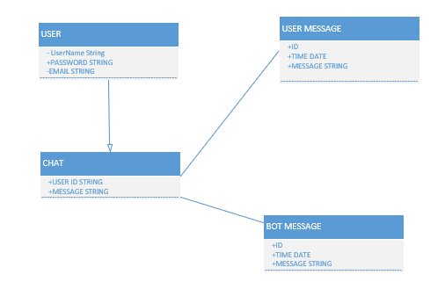

    - Object diagram:
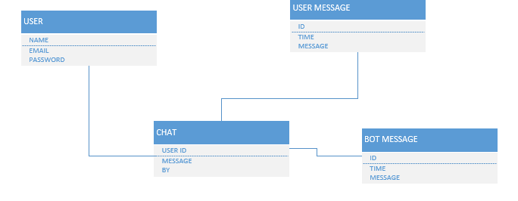
    - Sequecne diagram:
      - Chat:
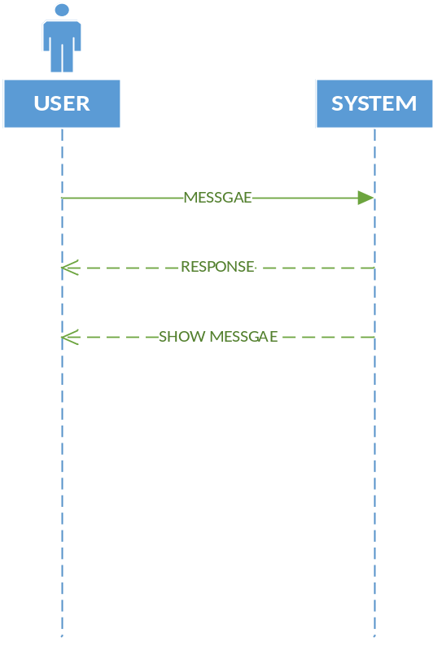

      - Login:
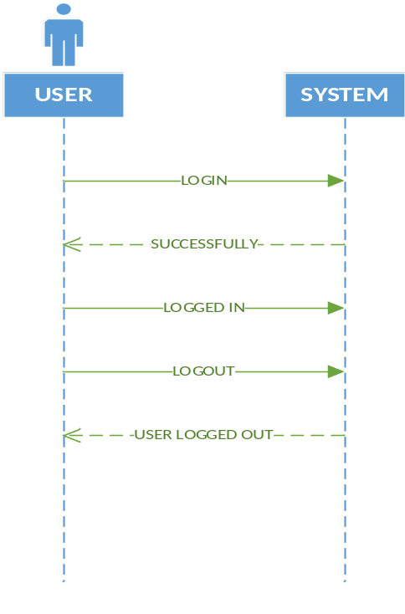

      - Register:
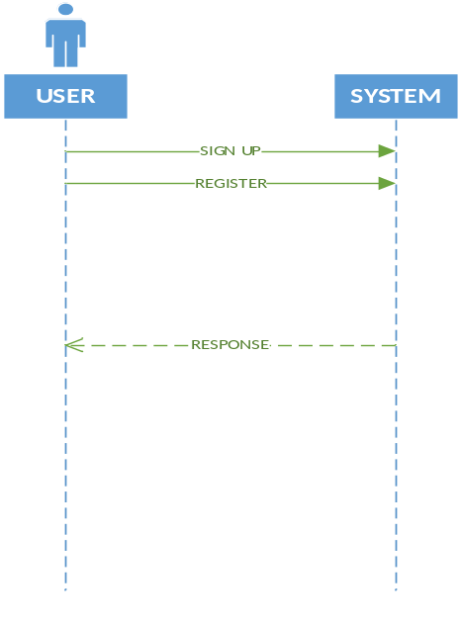

    - Activity Diagram:

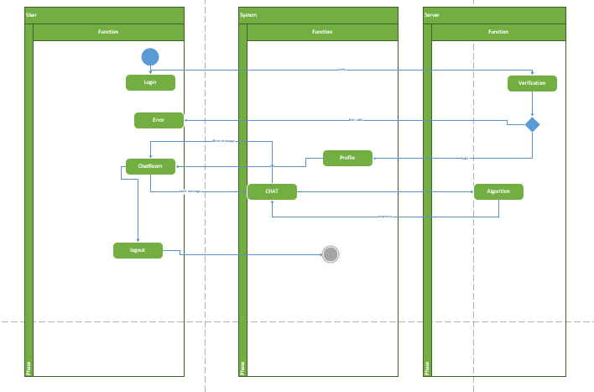

    - Collaboration diagram:
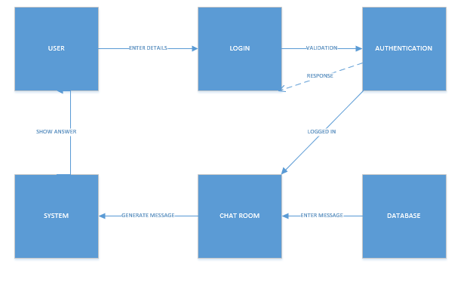

    - Use Case diagram:
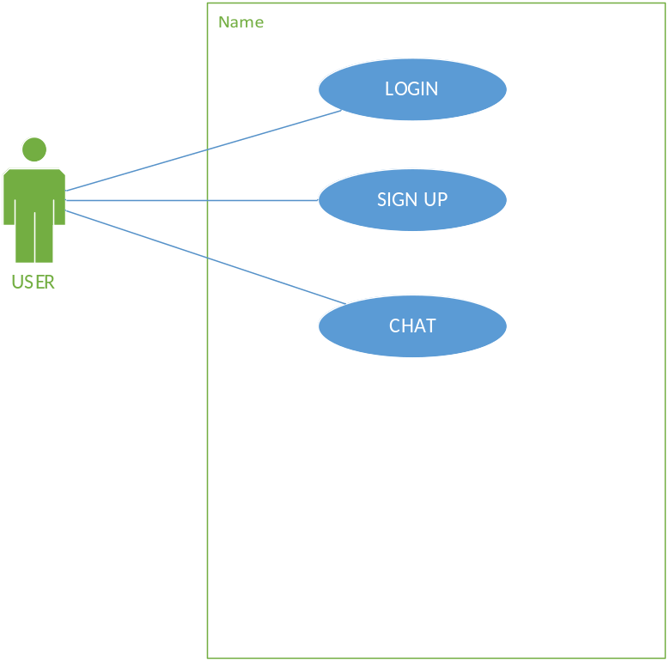

    - Component diagram:

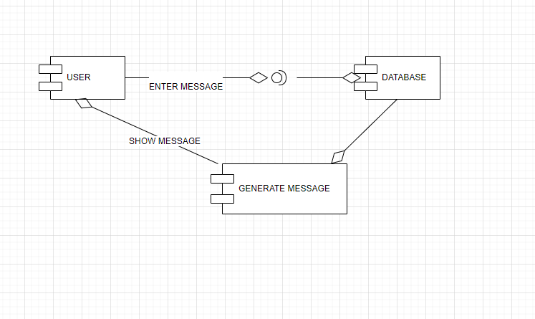

    - Deployment diagram:

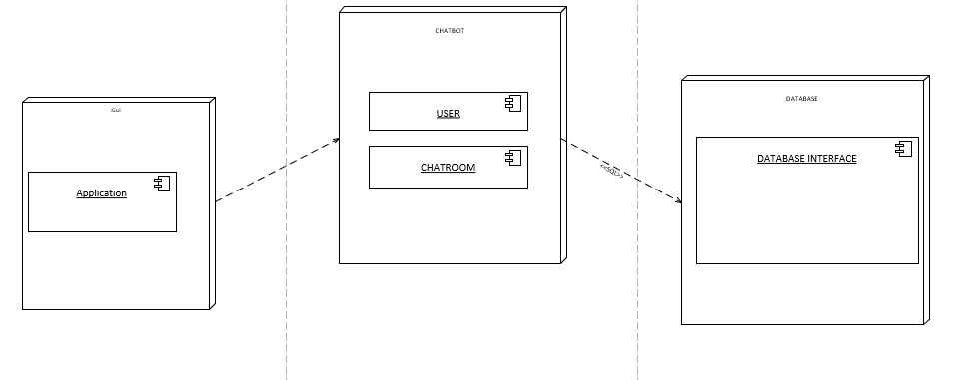

    - State Block diagram:

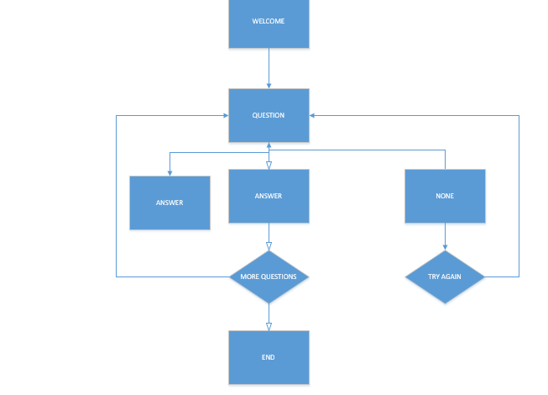

  - Test Cases:

    - Login:
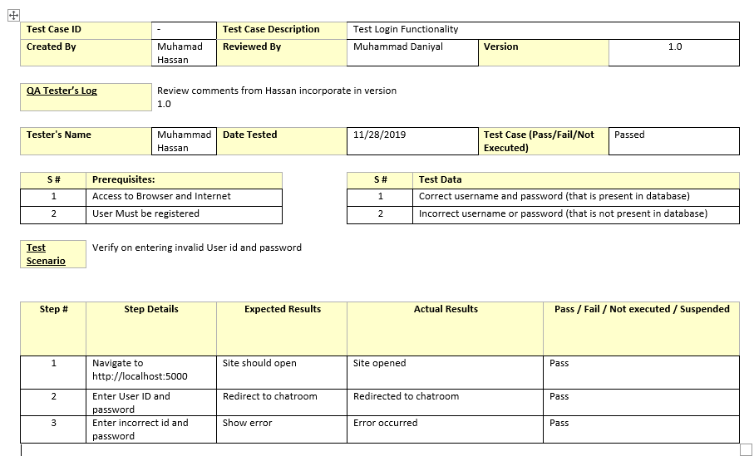

    - Register:
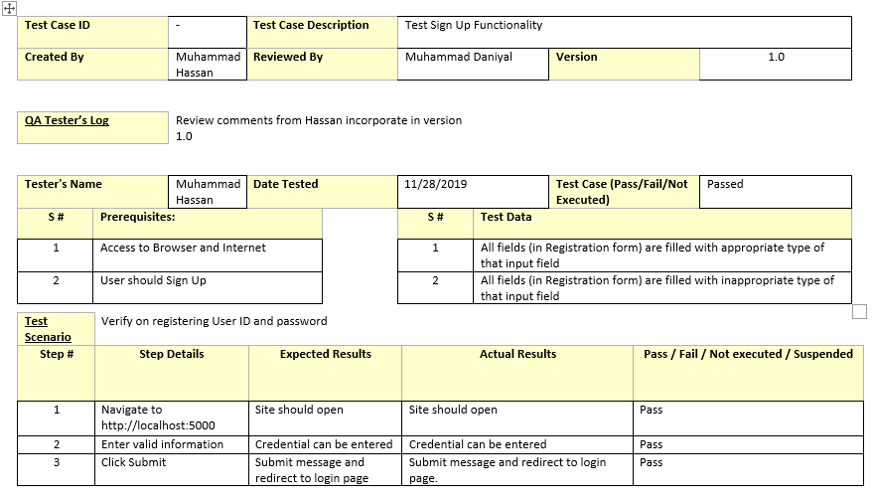
    - Chat:
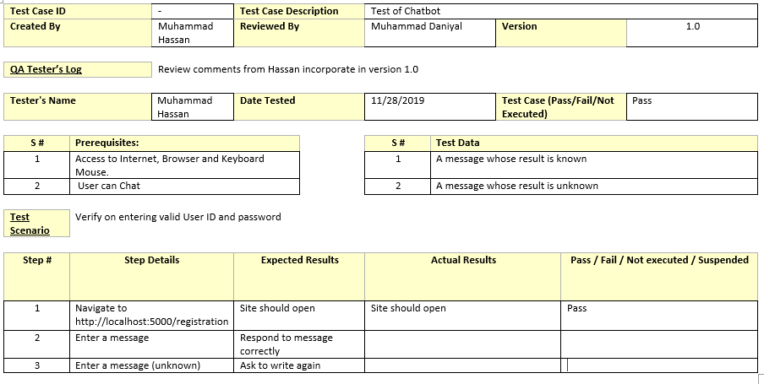

  - ERD:
